1. 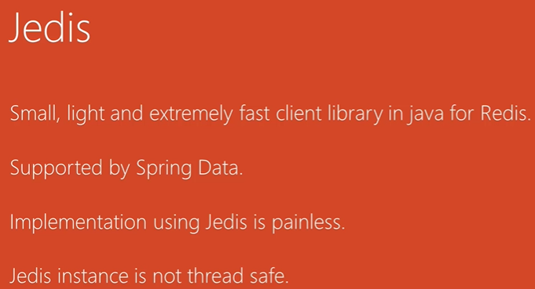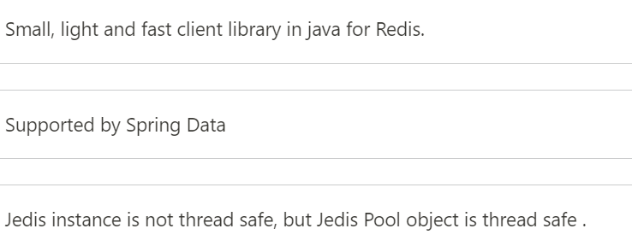  
   Jedis is **not thread-safe**. However, you can achieve thread safety using general pool.   
   By the way, Redis itself is **single threaded**. Single threaded program can provide concurrency at the I/O level by using the multiplexing mechanism and the event loop which is basically what Redis does.
2. Using the same Jedis instance from multiple threads from multiple threads at the same time will **result in socket connection errors**.  
   If we want to avoid that we need to use the Jedis instance in thread safe way by using **Jedis Pool**.  
   Jedis Pool object is thread-safe can be used in multiple threads at the same time.
3. **Benefits of Jedis Pool**:
   1. Each time we send DB request to make a new connection.
   2. Pool keeps a no of connections opened based on the pool configuration.   
      When request comes, we take connection from the pool when done with the request, we send back the connection to the pool.
4. 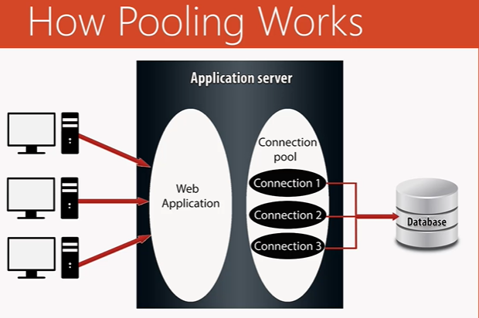  
   **NOTE**: When a request comes and all connections are busy, a new connection can be created based on the configuration you provide.